Configuración de Paquetes – automatización

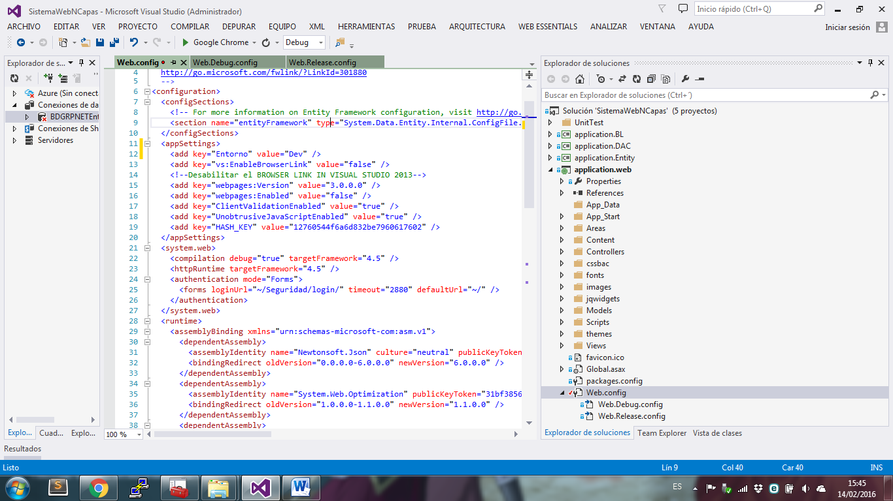

<add key="Entorno" value="Dev" />

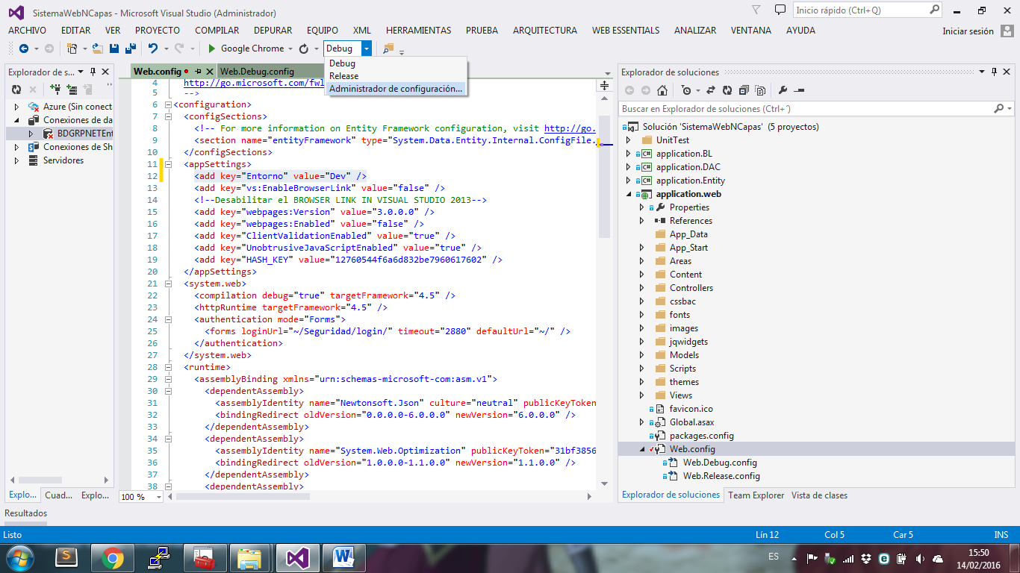

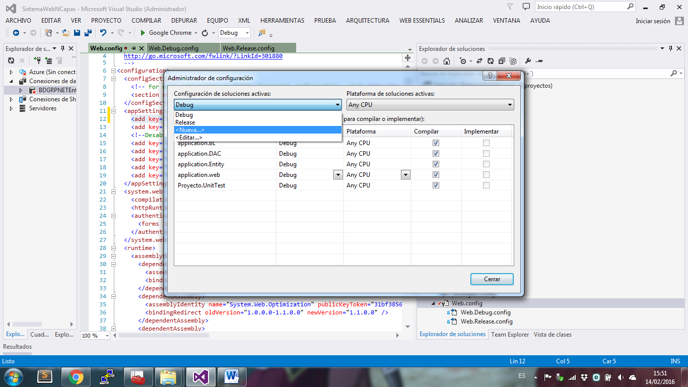

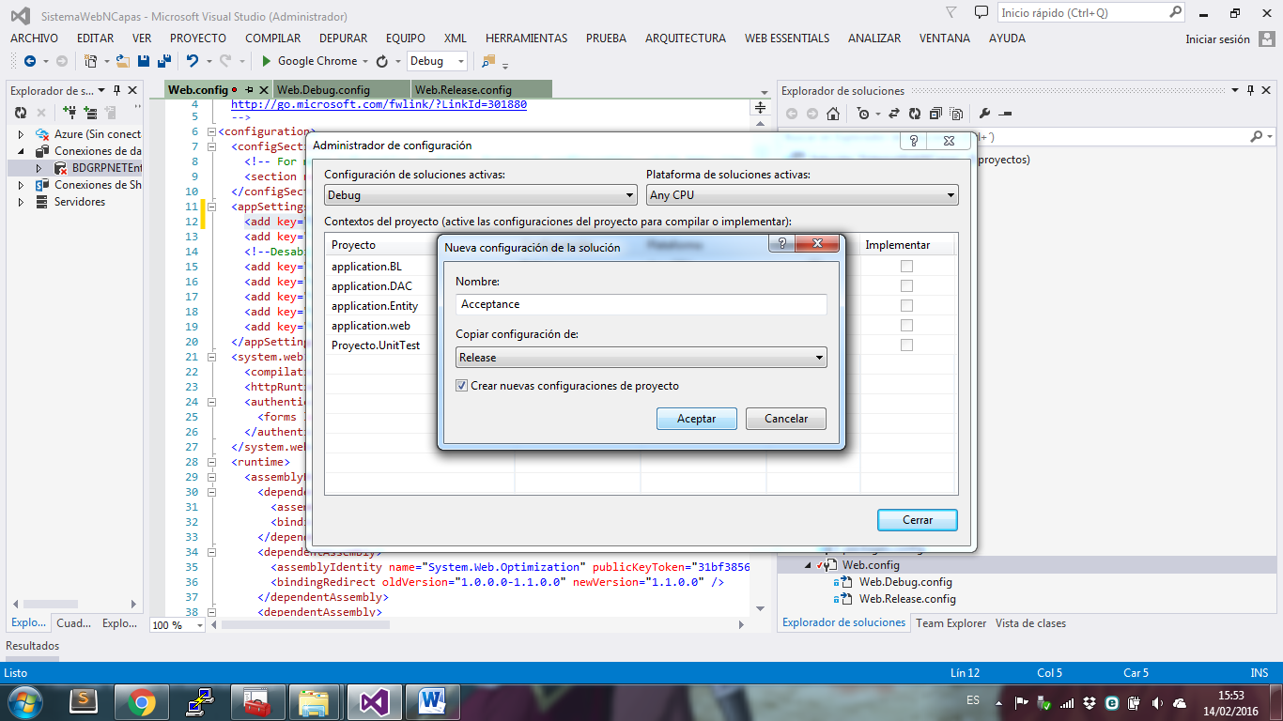 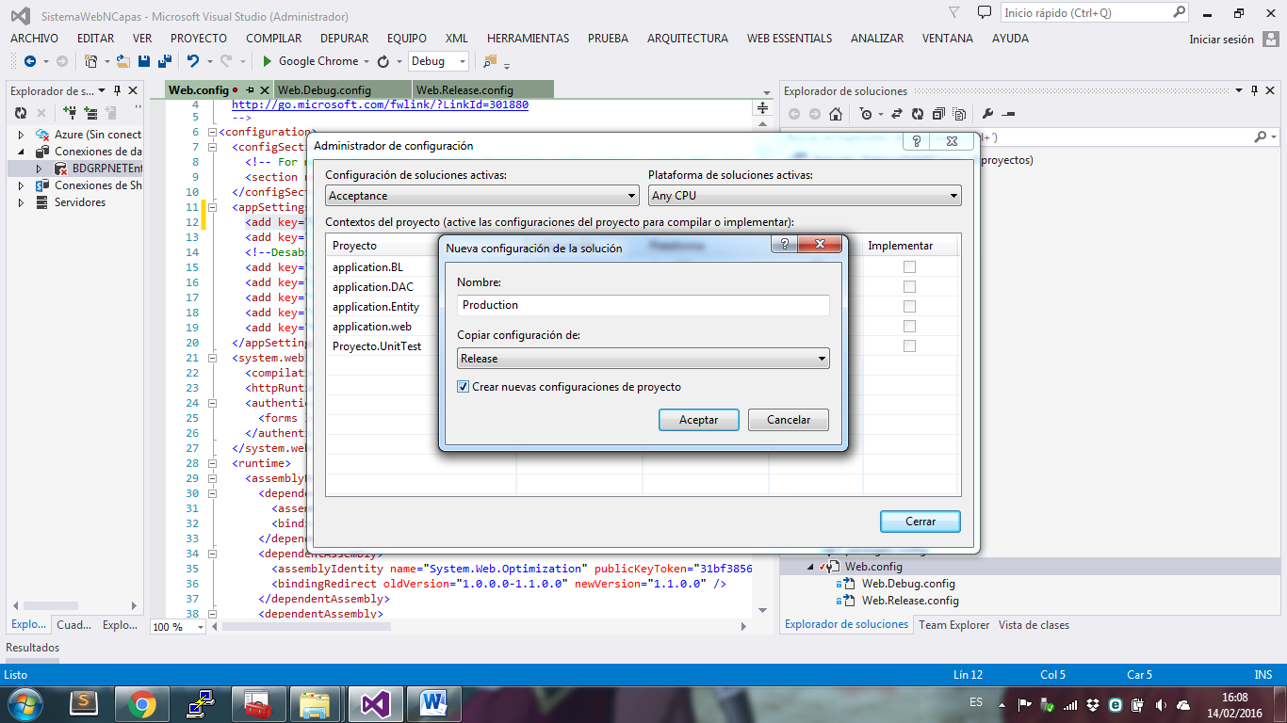

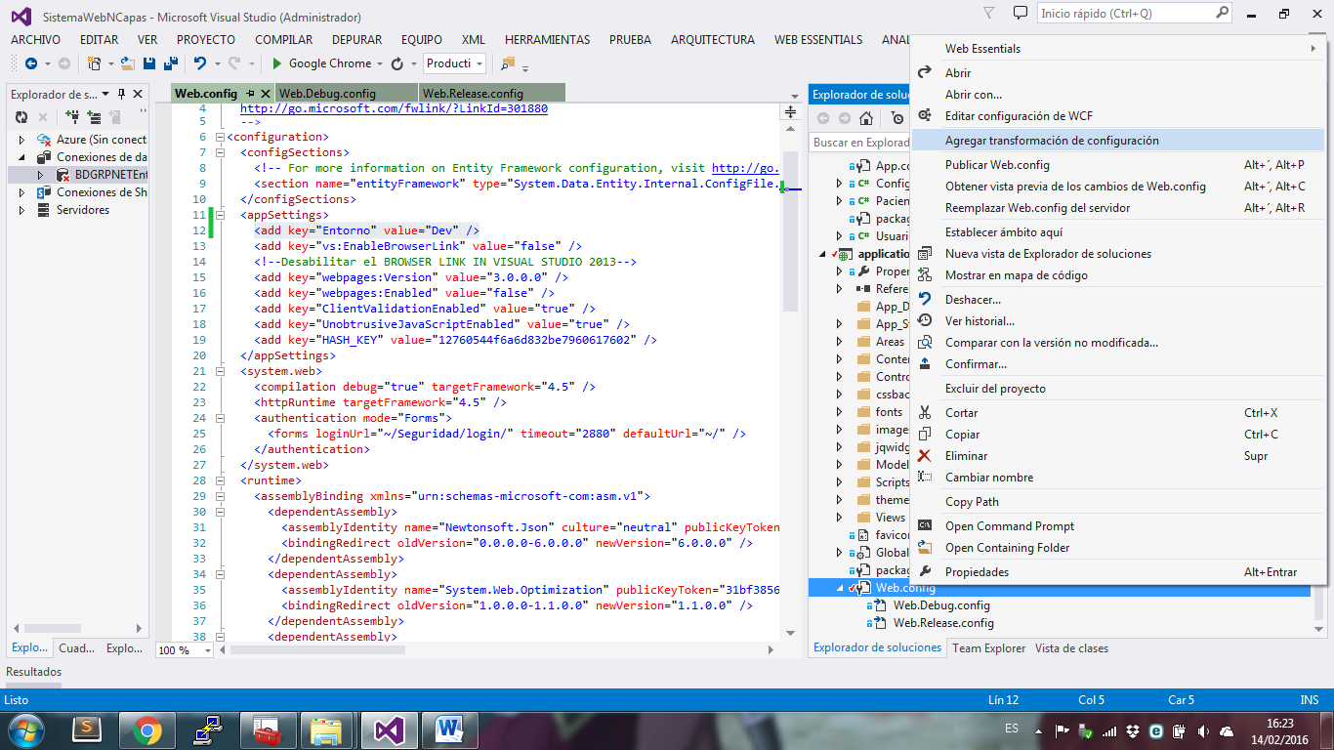 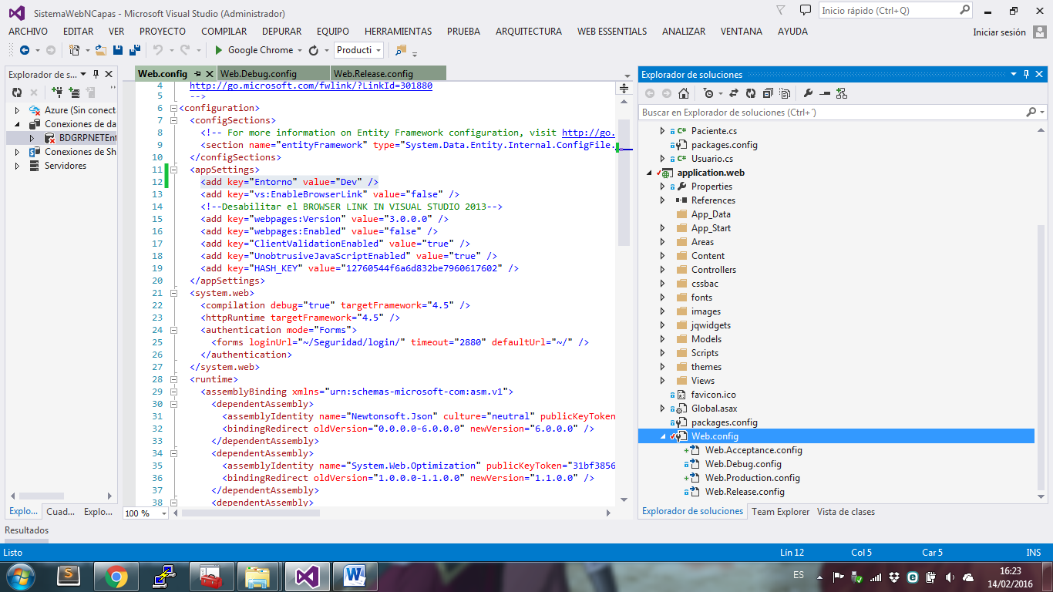

  <appSettings>

    <add key="Entorno" value="Automated" xdt:Locator="Match(key)" xdt:Transform="SetAttributes"/>

  </appSettings>

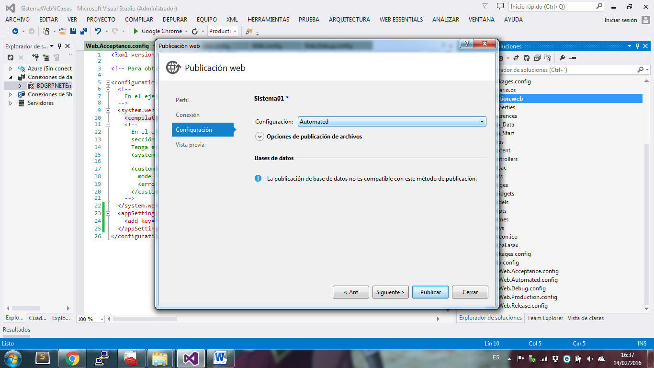

Crear el archivo Build.ps1

Nivel Administrador

Set-ExecutionPolicy Unrestricted

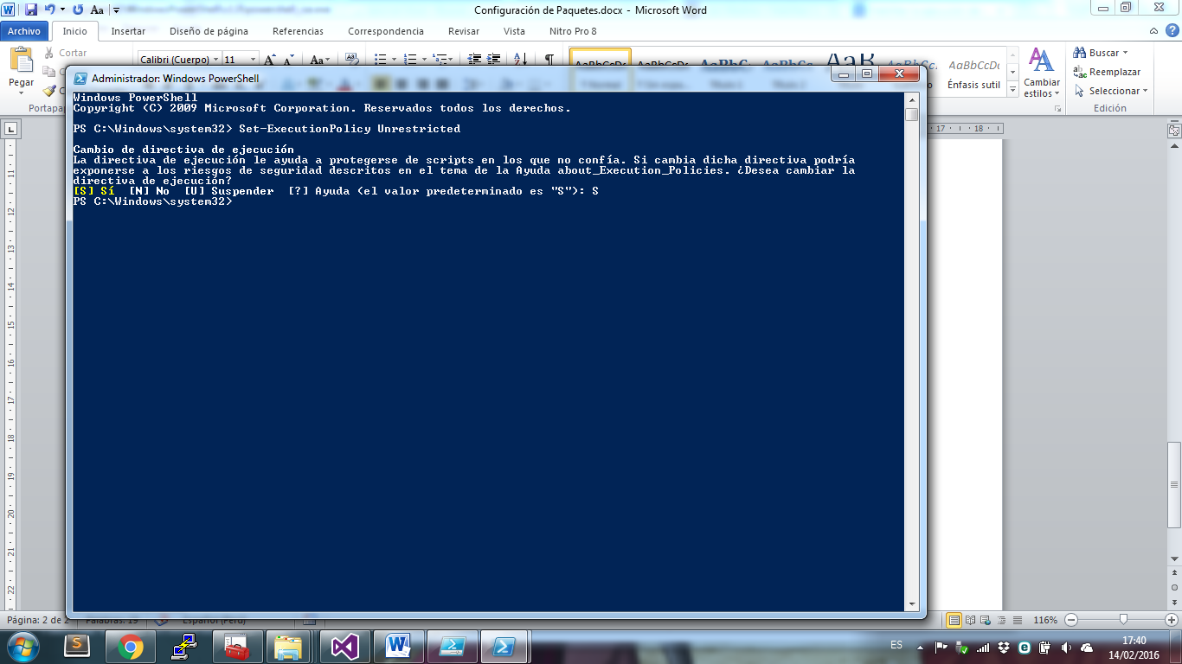

param(

[string]$version="2.0.2",

[string]$AppName

)

$msbuild = "C:\Program Files (x86)\MSBuild\12.0\Bin\MSBuild.exe"

$current = "$(Split-Path -parent $MyInvocation.MyCommand.Definition)"

$projectFilePath = join-path $current "\application.web\application.web.csproj"

$package_config_path = join-path $current "\Build\tools\config"

if( -not (Test-Path ".\Build") )

{

mkdir ".\Build"

}

Remove-Item .\Build\* -recurse -Force

& $msbuild $projectFilePath /t:Build /p:Configuration=Release /p:DeployOnBuild=True /p:PublishProfile=mipubweb

mkdir .\Build\tools\

## mkdir $package_config_path

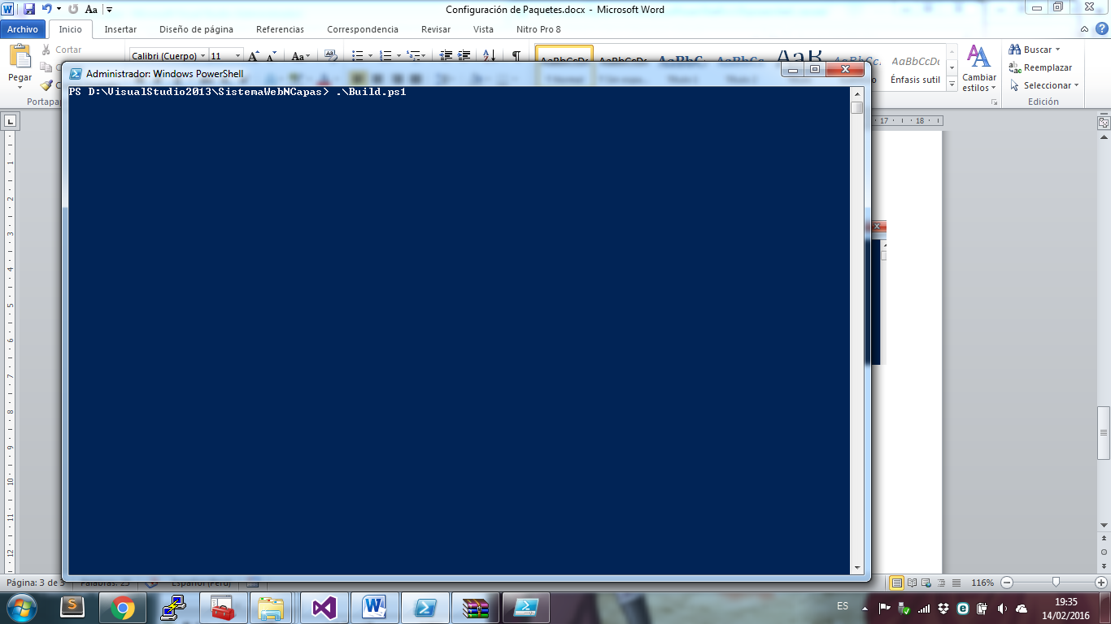

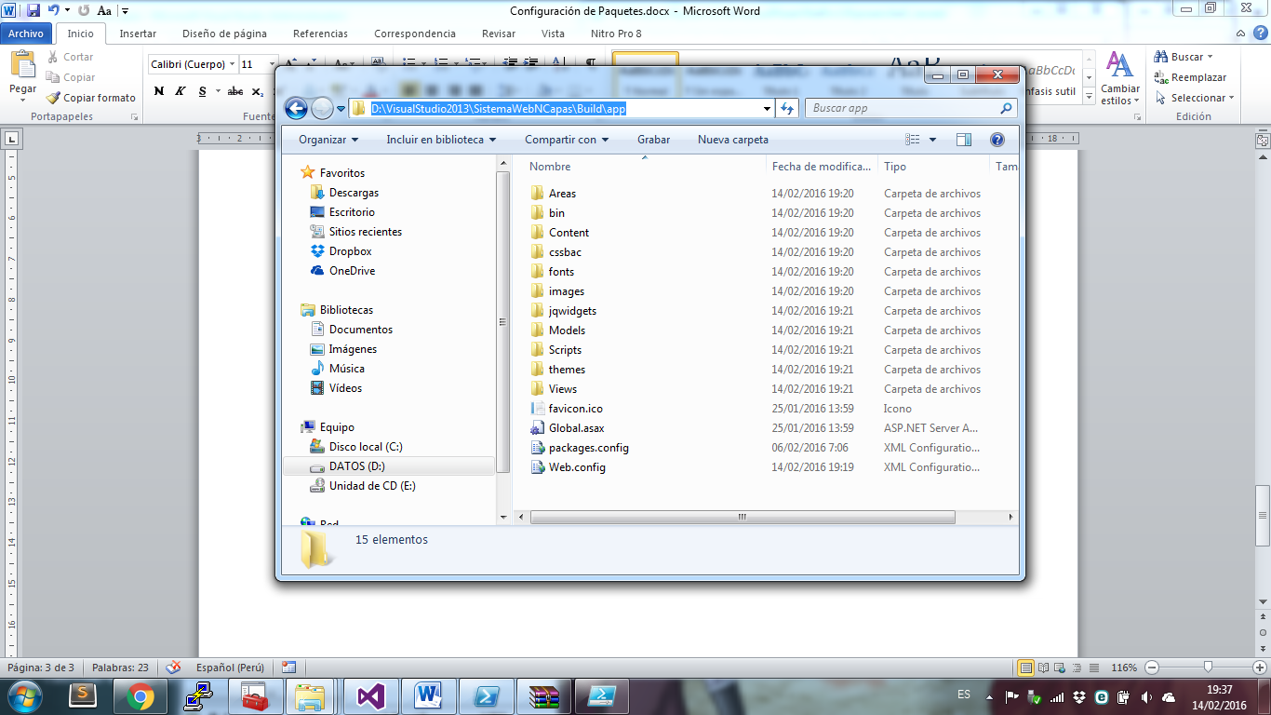

Crear una variable de entrono para nuget.exe

Crear un Package.nuspec

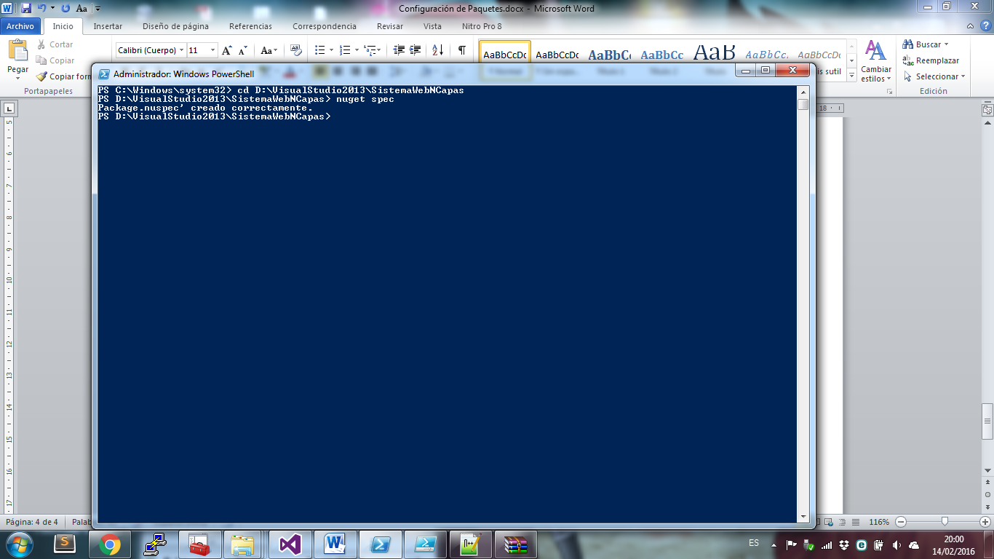

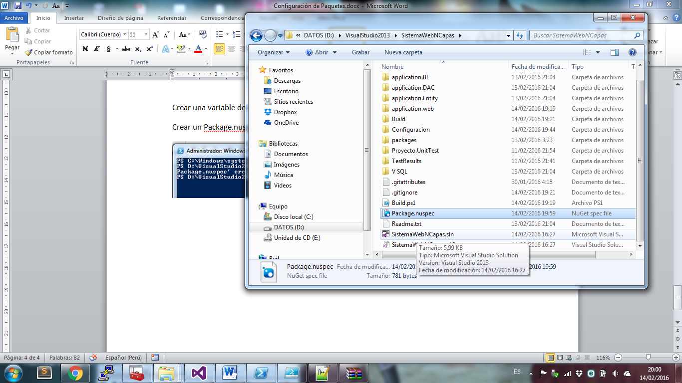 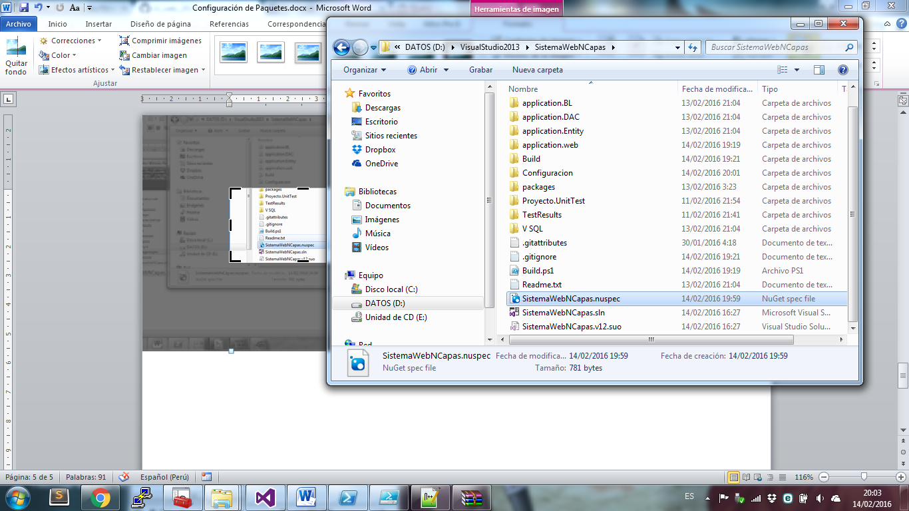

Cambiando el nombre a de Package.nuspec y SistemaWebNCapas. Nuspec

Instala en power Shell : iex ((new-object net.webclient).DownloadString('https://chocolatey.org/install.ps1'))